**Virtual – circuit network**

Virtual – circuit network is a category of packet switching network, where a virtual path is established between the source and the destination systems for data communication to occur. This path appears to the user as if it is a dedicated physical path, but actually is a logical circuit allocated from a managed pool of circuit resources as per traffic requirements. The network resources forming parts of this path can be shared by other communications, however, is not visible to this user.

**Virtual Circuit** is the computer network providing connection-oriented service. It is a connection-oriented network. In virtual circuit resource are reserve for the time interval of data transmission between two nodes. This network is a highly reliable medium of transfer. Virtual circuits are costly to implement.

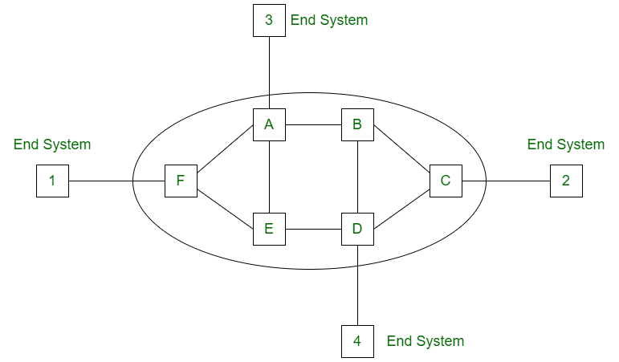

Features of Virtual – Circuit Network

* Virtual – circuit switching is done at the network layer of the communication system.
* In these networks, the path between the source and the destination nodes that is followed by first data packet gets allocated. All other data packets transmitted between them will use the same path.
* All the resources like buffers and bandwidth get reserved before the transmission, and all data packets consume same resources.
* Since all packets follow the same path, a common header and routing information is used by them.
* They provide greater reliability and less complexity owing to fixed paths and fixed resources.

Phases of Virtual - Circuit Transmission

There are three phases of transmission by virtual circuits, set up, data transfer and teardown.

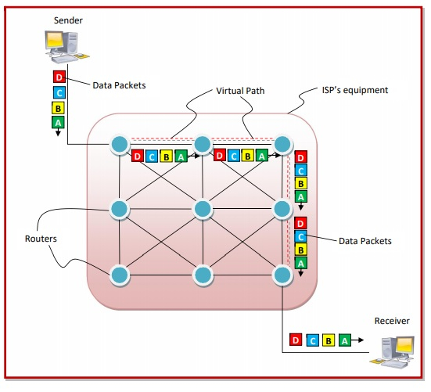

* **Set up Phase** − In this phase, a virtual circuit or a route is established from the source to the destination through number of switches. The source and destination use global addresses using which the switches make routing table entries.
* **Data Transfer** − Once the virtual circuit is set up, all packets follow the route established during the set up phase adhering to the routing tables.
* **Teardown Phase** − When data transfer is complete, the source sends a teardown request. The destination responds using a teardown confirmation. The switches flush their routing table entries, thus relinquishing the circuit.

In the following diagram, we can that a virtual circuit is created, as denoted by the dotted lines, and all the packets from the sender to the receiver are being routed along this virtual circuit.

# **Routing Algorithms**

**Routing**is the process of establishing the routes that data packets must follow to reach the destination. In this process, a routing table is created which contains information regarding routes that data packets follow. Various routing algorithms are used for the purpose of deciding which route an incoming data packet needs to be transmitted on to reach the destination efficiently.

A routing algorithm is a procedure that lays down the route or path to transfer data packets from source to the destination. They help in directing Internet traffic efficiently. After a data packet leaves its source, it can choose among the many different paths to reach its destination. Routing algorithm mathematically computes the best path, i.e. “least – cost path” that the packet can be routed through.

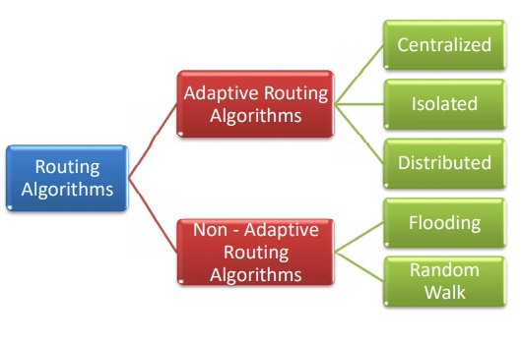

**Classification of Routing Algorithms:** The routing algorithms can be classified as follows:

1. **Adaptive Algorithms –**   
   These are the algorithms that change their routing decisions whenever network topology or traffic load changes. The changes in routing decisions are reflected in the topology as well as the traffic of the network. Also known as dynamic routing, these make use of dynamic information such as current topology, load, delay, etc. to select routes. Optimization parameters are distance, number of hops, and estimated transit time.

Adaptive routing algorithms, also known as dynamic routing algorithms, makes routing decisions dynamically depending on the network conditions. It constructs the routing table depending upon the network traffic and topology. They try to compute the optimized route depending upon the hop count, transit time and distance.

Further, these are classified as follows:

* **(a) Isolated –** In this method each, node makes its routing decisions using the information it has without seeking information from other nodes. The sending nodes don’t have information about the status of a particular link. The disadvantage is that packets may be sent through a congested network which may result in delay. Examples: Hot potato routing, backward learning.

This algorithm procures the routing information by using local information instead of gathering information from other nodes.

* **(b) Centralized –** In this method, a centralized node has entire information about the network and makes all the routing decisions. The advantage of this is only one node is required to keep the information of the entire network and the disadvantage is that if the central node goes down the entire network is done. The link state algorithm is referred to as a centralized algorithm since it is aware of the cost of each link in the network.

It finds the least-cost path between source and destination nodes by using global knowledge about the network. So, it is also known as global routing algorithm.

* **(c) Distributed –** In this method, the node receives information from its neighbors and then takes the decision about routing the packets. A disadvantage is that the packet may be delayed if there is a change in between intervals in which it receives information and sends packets. It is also known as a decentralized algorithm as it computes the least-cost path between source and destination.

This is a decentralized algorithm that computes the least-cost path between source and destination iteratively in a distributed manner.

**2. Non-Adaptive Algorithms –**   
These are the algorithms that do not change their routing decisions once they have been selected. This is also known as static routing as a route to be taken is computed in advance and downloaded to routers when a router is booted.

Further, these are classified as follows:

Non-adaptive Routing algorithms, also known as static routing algorithms, construct a static routing table to determine the path through which packets are to be sent. The static routing table is constructed based upon the routing information stored in the routers when the network is booted up.

* **(a) Flooding –** This adapts the technique in which every incoming packet is sent on every outgoing line except from which it arrived. One problem with this is that packets may go in a loop and as a result of which a node may receive duplicate packets. These problems can be overcome with the help of sequence numbers, hop count, and spanning trees.

In flooding, when a data packet arrives at a router, it is sent to all the outgoing links except the one it has arrived on. Flooding may be uncontrolled, controlled or selective flooding.

* **(b) Random walk –** In this method, packets are sent host by host or node by node to one of its neighbors randomly. This is a highly robust method that is usually implemented by sending packets onto the link which is least queued.

This is a probabilistic algorithm where a data packet is sent by the router to any one of its neighbours randomly.